High Commission of India
Suva

Press Release

India’s Signs Cooperation Agreement worth FJ$ 5.9 million to Support Fijian Micro and Small Businesses Grant Facility
(MSBG Facility)

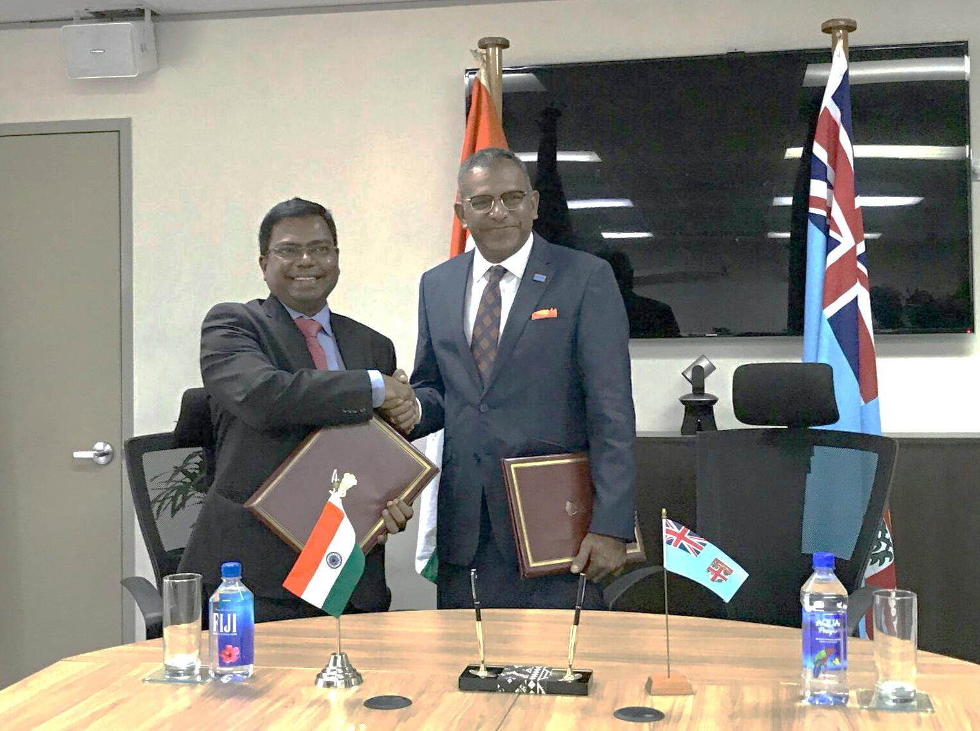

Indian High Commissioner and Hon’ble Minister of Industry, Trade and Tourism,
Lands and Mineral Resources, Government of Fiji signing a Memorandum of Agreement for Government of India’s assistance of FJ$5.9mn (eq. US$2.8mn) to Fijian SME Sector
___________________________________________________________________________________

His Excellency Mr. Faiyaz Koya, Hon’ble Minister of Industry, Trade and Tourism, Lands and Mineral Resources and His Excellency Mr. Vishvas Sapkal, High Commissioner of India to Fiji signed a Memorandum of Agreement (MoA) on 27 February 2018 at Suva for Government of India’s assistance to Fijian SME Sector for $5.9mn (eq. US$ 2.8mn). This Agreement has been signed in continuation of the Memorandum of Agreement signed between the two countries on 21 June 2016 for assistance of $4.7 million (eq. US$ 2.2mn) which has already been disbursed to the Government of the Republic of Fiji last year.

Signing of this MoA brings the total assistance to SME sector by Government of India to US$ 5 million. During the visit of His Excellency Mr. Narendra Modi, Hon’ble Prime Minister of India to Fiji in November 2014, India had pledged US$ 5 million as assistance to the Fijian SME sector.

Addressing mediapersons present on the occasion, Hon. Faiyaz Koya thanked the Government of India for their confidence in this initiative of the Government of Fiji and for their continued support. Hon. Minister informed that in the previous phase, the Indian Government’s assistance of FJ$ 4.7mn directly reached 4752 Fijian beneficiaries and the FJ$ 5.8mn assistance provided in current phase is expected to benefit 5900 individuals. Hon. Minister said that there were so many success stories coming out of that phase while underlining the positive results from the MSGB Facility. Hon. Minister also thanked H.E. Mr. Vishvas Sapkal, Indian High Commissioner to Fiji for his continued support. High Commissioner Sapkal expressed his satisfaction and appreciation for the Government of Fiji for successful implementation of the scheme and congratulated the Government for the same. He stressed that India is committed development partner of Fiji. Highlighting the role of SME sector’s growth in the overall growth of any economy, the High Commissioner informed the guests that similar schemes were being implemented in India as well with remarkable success.

Fijian Micro and Small Business Grant Facility (MSGB Facility) is an initiative of the Fijian Government designed to provide grants to recipients for start-ups for micro and small businesses as well as assistance to existing micro and small businesses. The Grant covers applicants from a vast range of activities such as canteen businesses, poultry, bee keeping, livestock farming, market vending, bakery, sewing, roadside stalls, tailoring and handicraft businesses etc. amongst others by providing them FJ$1000 each to start these activities.

27 February 2018
Suva

