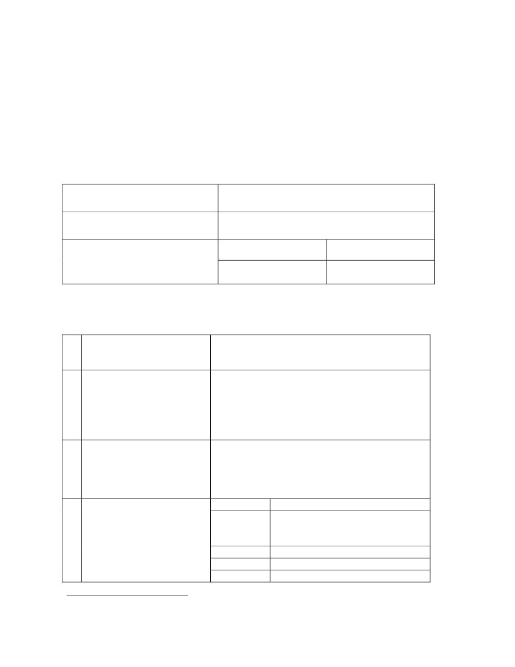

Government of India
Ministry of External Affairs
Technical Cooperation Division
DEPUTATION OF EXPERT FROM INDIA UNDER THE
INDIAN TECHNICAL AND ECONOMIC COOPERATION (ITEC)
PROGRAMME
APPLICATION FORM
Name of the host country
Designation of the proposed
Expert
Period of deputation
From
dd/mm/yy
To
dd/mm/yy
Part – I
TO BE FILLED BY HOST GOVERNMENT
1
Description
project. 1
of
the
2
Aims and objectives to
be achieved through the
proposed deputation of
the Expert
3
Description of staff to be
attached with the Expert
on the project.
4
Place of deployment,
address and telephone
number.
Place
Address
Telephone:
Fax :
Email :
1
(Please attach separate sheets if space is not enough; also attach detailed documentation (including statistics)
regarding present status and future plans.
Part – II
SPECIFICATIONS FOR THE POST 2
5
Duties of the Expert
(Job description)
6
Educational/Technical
Qualifications required
7
Work Experience
required
8
Field of Specialization –
(Type of material, equipment
and machinery etc. with which
the Expert is expected to be
familiar)
2
[Please attach separate sheet(s), if space is not enough in these columns]
Part – III
UNDERTAKING TO BE GIVEN BY THE HOST GOVERNMENT
The Host Government hereby undertakes:
To provide furnished accommodation suitable for the Expert and members of
his family;
To pay subsistence allowance to the Expert while on internal tour away from
Headquarters;
To incur expenditure on internal travel or provide transport to the Expert on
official tour/duty;
To grant leave to the Expert as admissible;
To extend free hospital and medical treatment to the Expert and members of
his family;
To exempt the Expert and members of his family from payment of customs
duty on their personal effects when imported on first arrival within reasonable
period;
To exempt the Expert from paying income-tax;
To indemnify the Expert in respect of damages suffered/awarded against him
for actions performed in the course of official duty; and
If extension of deputation period by any time exceeding three months was
sought by the host Government, the cost of terminal passage, transportation of
baggage, Children Holiday Passage (restricted to two children) and return
Home Leave Fares of expert and entitled members of his family would be
borne by the host Government.
Date :
Place :
Authorized Signatory
Seal
Part – IV
CERTIFICATE TO BE GIVEN BY THE INDIAN MISSION
1. The ITEC Expert form has been personally scrutinized by the officer-in-charge of
ITEC work in consultation with HOM.
2. The Form is complete [in triplicate] in respect of answers to all questions and is
accompanied by required documentation and details of the project for which the
Expert is required.
3. The deputation of the Expert is required for the exact period of days/months/years.
The period of deputation has been discussed with the host Government which
considers it adequate and no extension would be necessary.
4. A note has been attached containing details of exact location of the place of Expert’s
deployment, its distance from the capital city, climate conditions, requirement of dress
and clothing, level of educational facilities available for Expert’s children (including
medium of instructions), hospital and medical facilities available, availability of food
items locally and to be brought from India, currency and its exchange rate, mode of
payment to the Expert and remittance facility to India.
5. The host Government has been apprised of the terms and conditions, and have
agreed to provide the requisite facilities to the Expert as per Part III of the form.
6. The host Government will provide secretarial assistance to the Expert, where
required.
7. A note on assessment of expected benefits to the host Government.
8. The proposed deputation does/does not form part of Joint Commission meeting held
on ____________ / agreement signed on _______________.
Signature and Seal of
Officer-in-charge of ITEC
in the Mission
Telephone No :
(Off. )
(Res. )
Remarks/Recommendations
of HOM/HOP.
Date :
Signature
(Seal – HOM/HOP)
DEPUTATION OF INDIAN EXPERT ABROAD –
GUIDELINES FOR SUBMISSION OF FORM
The Form, in triplicate, are required to be submitted to Technical
Cooperation Division of Ministry of External Affairs, New Delhi.
All the columns in the Form are required to be filled in and signed by the
Authorized Signatory with seal, wherever required, and submitted with
necessary documentations. Incomplete Form will not be entertained.
Each request for deputation of expert is required to be submitted in
separate Form.
The host Government is required to furnish in detail the “Specifications for
the Post’ in Part-II of the Form and also specify the period of deputation.
The Indian Mission is required to apprise the host Government about the
terms and conditions of the deputation of Expert.

